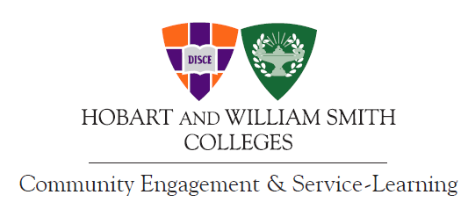

Community Partner of the Year: This award is presented annually to the person/agency who has consistently contributed to the civic development and leadership of Hobart and William Smith Colleges students. This award recognizes the inherent value of community collaborations and acknowledges with gratitude the time, energy and interest invested in the student service and learning experience. Nominators may be students, faculty, or staff.

Nominator’s Name: _____________________________________________________________________

Nominator’s Email Address: ______________________________________________________________

Nominator’s Daytime Phone Number: _______________________________________________________

Nominee’s Name: _______________________________________________________________________

Nominee’s Email Address: ________________________________________________________________

Nominee’s Daytime Phone Number: ________________________________________________________

Please include biographical summary and ways in which her or his/agency community commitment has been evidenced:

PLEASE SUBMIT YOUR NOMINATIONS BY April 15th (for review and selection by the Service-Learning Advisory Council)
Please return nomination forms to:
Katie Flowers kflowers@hws.edu
Center for Community Engagement & Service-Learning (CCESL)

Compass Award for Outstanding Engaged Student Scholarship:
This award is presented annually to a Hobart College or William Smith College student who has excelled in either a community-based research project or a service-learning course. The student work is academically rigorous and has a meaningful community impact. Nominators may be community partners, faculty, staff, or peers.

Nominator’s Name: _____________________________________________________________________

Nominator’s Email Address: ______________________________________________________________

Nominator’s Daytime Phone Number: _______________________________________________________

Nominee’s Name: _______________________________________________________________________

Nominee’s Email Address: ________________________________________________________________

Nominee’s Daytime Phone Number: ________________________________________________________

Please include biographical summary and ways in which her/his scholarship and community commitment has been evidenced:

PLEASE SUBMIT YOUR NOMINATIONS BY April 15th (for review and selection by the Service-Learning Advisory Council)
Please return nomination forms to:
Katie Flowers kflowers@hws.edu
Center for Community Engagement & Service-Learning (CCESL)

HWS Civically Engaged Faculty Award:
The Provost’s Office and The Center for Community Engagement and Service-Learning seek nominations for the annual “HWS Civically Engaged Faculty Award.” Campus Compact defines a civically engaged faculty member as one who has demonstrated “exemplary engaged scholarship, including leadership in advancing students’ civic learning, conducting community-based research, fostering reciprocal community partnerships, building institutional commitments to service-learning and civic engagement, and other means of enhancing higher education’s contributions to the public good.” Nominators may be community partners, faculty, staff, or students.

Nominator’s Name: _____________________________________________________________________

Nominator’s Email Address: ______________________________________________________________

Nominator’s Daytime Phone Number: _______________________________________________________

Nominee’s Name: _______________________________________________________________________

Nominee’s Email Address: ________________________________________________________________

Nominee’s Daytime Phone Number: ________________________________________________________

Please include biographical summary and ways in which her/his engaged scholarship and campus/community leadership been evidenced:

PLEASE SUBMIT YOUR NOMINATIONS BY April 15th (for review and selection by the Service-Learning Advisory Council)
Please return nomination forms to:
Katie Flowers kflowers@hws.edu
Center for Community Engagement & Service-Learning (CCESL)

