(First Year Seminars)

INSTRUCTIONS AND PROCEDURES FOR NEW COURSE PROPOSALS
Below are instructions and procedures regarding the process for getting new courses approved. Please read this information thoroughly before filling out the form.

I. The Committee on Academic Affairs will only consider proposals submitted electronically. Course proposal forms are available on the website.

Complete Sections A, B, and C. Section D will be completed by the COAA after action is taken on the proposal. BE SURE ALL APPROPRIATE SIGNATURES APPEAR ON THE FORM before submitting to the Registrar.

PLEASE USE ELECTRONIC SIGNATURE (Email approval or PDF scan of signature.)

All proposals must be completed electronically and submitted to the Registrar.

After the Registrar has determined that all necessary information and signatures are included, the course proposal will be reviewed by the Committee on Academic Affairs.

II. Administrative procedures following COAA action.
The COAA acts on the proposal and the Registrar records the action on the “New Courses Approved by COAA” page on the Registrar’s website. The instructor of the course and department chair are informed of the decision.

III. Procedure following course approval.
After the course is approved, the Registrar’s Office will load the course and the course description into the PeopleSoft System.
FIRST YEAR SEMINAR COURSE PROPOSAL (Rev. 2/17/20)
All proposals must be completed electronically.

PLEASE USE ELECTRONIC SIGNATURE (Email approval or PDF scan of required signatures.) Be sure all signatures are included BEFORE submitting proposal to the Registrar.

All FSEM instructors are asked to design courses that help HWS first-year students:
1. Develop improved critical thinking and communication skills and practices,
2. Enculturate themselves within the Colleges’ intellectual and ethical values and practices, and
3. Establish a strong network of relationships with peers and mentors on campus.

A. FSEM Information
Term to be first offered: Fall, Year:
- Seminar Title:
- Course Number:
- Short Title (Max of 30 characters only):

- Course Instructor(s): Each person listed below will teach this course in the fall. NOTE: If this is a group proposal, designate one of the instructors as the liaison with Academic Affairs and place an asterisk by the name.

- Course description and catalog copy. (Please attach a fuller description if needed.)

- Choose one of the following time periods:
_____ Period C4: MWF 12:00 PM-1:00 PM
_____ Period C10: TR 8:40AM-10:10 AM

B. Course Design
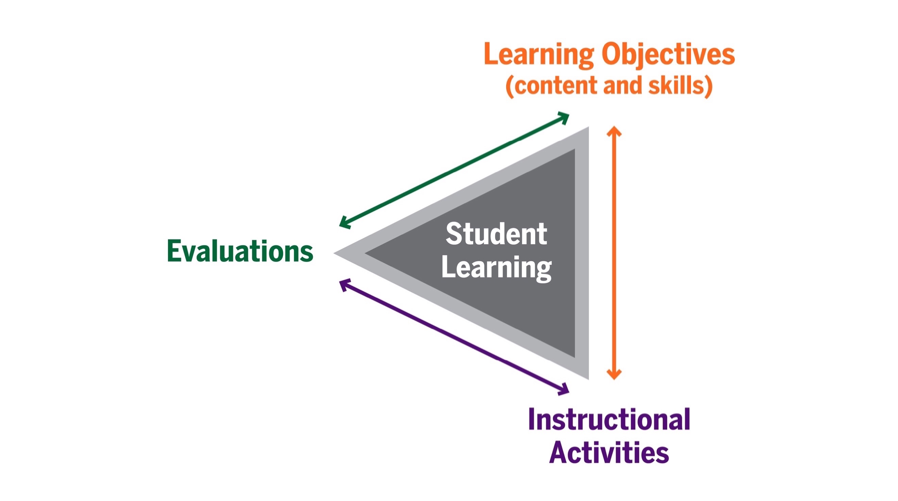
In preparing your answers to the questions below, please note that CoAA encourages clear articulation of the alignment among and between student learning objectives, instructional methods, and evaluation methods for the course.

Please also note that CoAA is looking for student learning objectives suitable for syllabi that are specific, precise, and able to be evaluated, as in the “better” examples below:

  - Vague Content/Skills Objective: Students [in Econ 201] will learn econometric tools and analysis.
  - Better: Students will practice using econometric tools to analyze provided data sets, interpreting their results in light of limitations of method and/or data & evidence, and presenting their findings in various ways.

  - Vague Content Objective: At semester’s end, students in [ ] will understand health and illness as socially constructed in cultural contexts.
  - Better: At the end of this semester, students in [ ] will be able to demonstrate how health and illness are socially constructed by comparing and contrasting ways in which different cultures conceptualize the body, perceive the human life cycle, and explain and treat illness.

  - Vague Skills Objective: Students [in intro] will use and cite sources in MLA style.
  - Better: Students will show improvement in following “best practices” for accurately summarizing, synthesizing, and citing sources using MLA style.

For assistance writing learning objectives that are specific, precise, and able to be evaluated, see: https://www.hws.edu/academics/ctl/pdf/learning_objectives.pdf

For help finding specific, precise verbs:
“Bloom’s Taxonomy” (from the Center for Teaching at Vanderbilt)
https://cft.vanderbilt.edu/guides-sub-pages/blooms-taxonomy/; VALUE Rubrics from AAC&U note
the affective rubrics, too: https://www.aacu.org/value-rubrics

For guidance writing learning objectives: “Writing Effective Learning Objectives” (from The Innovative Instructor Blog at Johns Hopkins U.) https://ii.library.jhu.edu/2016/07/20/writing-effective-learning-objectives/

- What key questions will be addressed in the course?

- What are the student learning objectives for the course? (Revised as needed, these learning objectives also should appear in the course syllabus, and can be used as the basis for the end of term student learning feedback form.)
  - Please include both skills/abilities objectives and content objectives.
  - Please ensure that objectives are specific, precise, and able to be evaluated.
  - Please refer to, use, or adapt as needed the FSEM Program Learning Objectives, listed here in short form (for complete learning objectives, see Appendix 2):
- Help students develop and exercise improved critical thinking skills.
- Help students improve their ability to read, accurately summarize, and analyze texts (“texts” broadly understood).
- Strengthen students’ communications skills and practices, especially academic written communication.
- Gain or further develop students’ knowledge, strategies, and skills needed to accomplish their HWS academic work.
- Gain or further develop students’ active, self-aware approach to their own learning.

- What instructional methods will assist students in reaching these objectives?

- What kind of evaluation methods will show that students have achieved the learning objectives/goals for the course?

- Please list potential readings and other relevant course materials.

C. Signatures required for COAA approval. *PLEASE USE ELECTRONIC SIGNATURE (Email approval or PDF scan of signature.

__________________________________ _______________________
FSEM Instructor Signature Date

____________________________________________________________
Print Name of FSEM Instructor

__________________________________ _______________________
Instructor’s Dept/Program Chair Signature Date

____________________________________________________________
Print Name of Instructor’s Dept/Program Chair

___________________________________________________
Print Name of Instructor’s Dept/Program

______________________________________
Associate Dean of Faculty for the FY Program

D. Action of the Committee on Academic Affairs:

Approved ___________ Not Approved ____________

Revise and resubmit ____________

_________________________________________ _______________
(Signature) Chair, Committee on Academic Affairs Date

Additional Remarks:
Appendix 1: FSEM Program Course Design Guidelines
These overarching goals were then articulated as the following Guidelines for FSEM Course Design, in place since approval by CoAA in 2017, and revised and approved again in Spring 2021.

All FSEM courses should:
- Enact advising, teaching, and learning methodologies that provide all students with an educational environment in which they are respected, valued, and supported.
- Emphasize equally content, skills and scholarly habits of mind:
  - The FSEM Learning Objectives framework, below, can help make this approach clear.
  - Build into the course both explicit academic advising to help students understand HWS academic norms/policies and implicit academic mentoring to help students acquire scholarly habits of mind.
- Follow the design guidelines for a "writing instructive" approach: see "Designing a 'Writing Instructive FSEM" [Appendix A].
- Scaffold complex assignments to help all students achieve expectations that are high and realistic.
- Rely on active learning techniques like interactive lecture and discussion that promote all students’ learning agency and are inclusive and equitable; these techniques should drive most class meetings.
- Reach a diverse audience of institutional newcomers: specifically, instructors are asked to craft explanations, expectations, policies, and other materials that are clear, accurate, thorough, inclusive, and equitable, at both assignment and course levels.

To further ensure that FSEM courses offer a robust, common, consistent foundation for student academic success, in the Spring of 2019 the FSEM Fellows began research to develop a framework that would help faculty articulate FSEM learning objectives to students, below.
Appendix 2: FSEM Program Student Learning Objectives
(Approved by FSEM Fellows/CoAA 5/2019, revised and approved in 2021)
In their FSEM courses, all first-year students will:
- Develop and exercise improved critical thinking skills.

- All FSEM students should explore critical thinking strategies for revealing, interrogating, and dismantling practices, modes of expression, and policies that have privileged certain groups while excluding others, in ways appropriate to all or any among
  - the teaching and learning methodologies,
  - course content, and
  - disciplinary perspectives of the FSEM course.

- Because “critical thinking” is the most often referenced but least often defined learning objective in FSEM syllabi, the Fellows all offer five options for critical thinking objectives, below, suggesting that students may practice:
- Building “habits of mind characterized by the comprehensive exploration of issues, ideas, artifacts, and events before accepting or formulating an opinion or conclusion”; such comprehensive exploration should include perspectives and ideas from underrepresented communities.
- Comprehending the difference between inference and opinion, and practicing the former.
- Experiencing objectives 2-5, below, as critical thinking in action.
- Creating, evaluating, applying, and analyzing, especially analyzing assumptions both explicit and implicit, including implicit biases that, when unexamined, can unintentionally prejudice us against certain groups’ perspectives.
- Learning to identify and question underlying assumptions, even and especially when doing so causes discomfort.

- Improve their ability to read, accurately summarize, and analyze texts (“texts” broadly understood).
- Faculty have implemented and articulated a critical reading objective in many ways, suggesting variously that students in an FSEM should practice some combination of
    - Summarizing and critiquing key claims in primary or secondary texts,
    - Engaging in “close reading,”
    - Identifying implicit and explicit arguments in both primary and secondary texts,
    - Accurately and critically reading and annotating texts,
    - Summarizing accurately, analyzing, and later synthesizing source material,
    - Critically analyzing texts, especially but not limited to critical analysis of texts and modes of expression that privilege some while excluding others.

- Strengthen communications skills and practices, especially academic written communication. At minimum, students should:
- Synthesize readings/sources and their own ideas,
- Enhance the knowledge, abilities, and flexibility needed to navigate writing in multiple disciplines across four college years by
- Practicing interpreting writing assignments and responding appropriately;
- Being introduced to the reality of multiple, competing definitions of “good” college-level academic writing, and strategies for navigating these multiple definitions;
- Taking a piece of writing through the process of revision, preferably with feedback from HWS resources;
- Having experience of any of the HWS support resources for improving writing,
- Articulating their writing strengths and weaknesses, and HWS-relevant options for continued growth;
- Demonstrating improvement in an aspect of their academic writing, to instill and reinforce the belief that they not only are capable of continuing to expand their academic writing skills, but that successful college students expect to do so;
- Interrogate modes of expression as potential sites that can privilege some while excluding others,
- Experience class discussion as an opportunity to practice oral communication and active listening skills in an environment of mutual learning and respect, helping to create safe, supportive learning environments and effectively engage with others in learning processes.
4. Gain or further develop knowledge, strategies, and skills needed to accomplish their HWS academic work. At minimum, students should:
- Critically explore institutional practices, modes of expression, and policies, beginning with but not limited to building awareness that some institutional practices, modes of expressing, and policies may privilege access for some while excluding others.
- Know how/where to access knowledge on and articulate three aspects of academic honesty:
  - HWS academic honesty policy as stated in the Community Standards Handbook,
  - Rationale(s) for acknowledging sources in an academic environment (the “why”),
  - Where/how they can learn more about at least one of the three most common methods (APA, MLA, or Turabian [aka “Chicago”]) for citing sources.
- Practice evaluating, selecting, using, and citing sources to inform their HWS academic work,
- Understand their advisor’s role and their own responsibilities as advisees,
- Experience at least one HWS academic support resource,
- Review the HWS curriculum, especially those elements that can help FY students select Spring semester courses,
- Navigate PeopleSoft and other HWS infrastructure, as necessary.
- Gain, as appropriate to the FSEM course and determined by a combination of the student’s own needs and the FSEM instructor, some among the many other sets of HWS information, effective student strategies, and specific skills needed to successfully navigate college.
5. Gain or further develop an active, self- and socially-aware approach to their own learning, including but not limited to examining ways in which learning methods they themselves engage in may be enhanced through greater competency in cross-cultural, inclusive communication that encourages safe, supportive environments for learning.

Because FSEM faculty have implemented and articulated this “active, self- and socially-aware approach to learning” in many ways, the FSEM fellows offer the following options, suggesting that students in an FSEM may practice some combination of

- Self-assessing knowledge and skills progress using several methods,
- Reflecting on and analyzing the progress in their individual learning,
- Articulating norms related to good academic citizenship and effective growth as students at HWS,
- Venturing into new personal and/or academic territory,
- Modeling themselves as students on their FSEM Mentors or Writing Colleague,
- Setting specific immediate and long-term learning objectives for themselves,
- Approaching their college work and life as thoughtful professionals able to critique institutional and social systems of inequity,
- Taking an active role in their own comprehension of material and use all available HWS resources, from the Librarians to Canvas to the CTL to our Writing Colleagues, and more.

Appendix 3: Designing a Writing Instructive FSEM
(CoAA approved 2017, 2021)

A writing instructive FSEM fosters an environment in which student writing can improve when instructors:

- Enact writing teaching and learning methods that enable student learning via safe, supportive learning environments, and that minimize or help to dismantle assignment and feedback practices, that privilege some while excluding others.

- Balance low-stakes and high-stakes writing (“low-stakes” = writing to learn or “training writing” methods).

- Infuse writing as a method for content learning (for a variety of useful methods, see Gottschalk & Hjortshoj Chapter 5, or Bean Chapter 7 and 8); see A, above.

- Scaffold long and/or complex assignments (see G & H Chapter 2, Bean sections 2 and 3) .

- Provide students with feedback early—by week 2 or 3 of the semester—and keep the writing and other workload fairly even throughout the term.

- Emphasize the writing process through feedback and revision; emphasize improvements and gains as well as deficits and needs (see G& H chapter 3-5 , Bean part 4).

- Integrate writing support resources (just as with office hours, students often need incentive to try HWS writing resources a first time).

- Keep the amount of writing and feedback reasonable—for them, for you.

(Strongly) Suggested Writing Goals
By the end of term, students should be able to:
• understand that there exist multiple, competing expectations for college-level academic writing (multiple definitions of “good” writing).
• improve in synthesizing readings/sources with their own ideas.
• know where to access more information about and begin to understand three aspects of academic honesty: HWS academic honesty policy as stated in the Community Standards Handbook, the rationale for citation of sources, and the basic use one citation method.
• improve in one aspect (possibly minor) of their academic writing.
• understand their own writing strengths and weaknesses AND options for continued improvement in the Spring and throughout their college career (remember that advisors can require WRRH 100).
• believe they can & should continue to learn more about college writing (studies show that the most important factor in student writing success is the belief that they not only can learn more about how to write well after high school, but that they should seek to do so).

Useful Writing Texts for Students
Hjortshoj, Keith. The Transition to College Writing. New York: Bedford/St. Martin’s, 2009.
• A guide to the understanding the why of college writing.
OWL at Purdue (Links to an external site.).
• The online writing center of Purdue University. Content similar to “handbooks,” at no cost.
Graff, Gerald & Birkenstein, Cathy. They Say I Say: The Moves That Matter in Academic Writing. New York: W.W. Norton & Company, 2014.
• A manageable and engaging guide to academic writing that provides techniques and best practices for introducing, explaining, and incorporating other’s writing into their own ideas.

See HWS Curricular Goals 1 and 2.
This framework is based on, first, the Fellows’ analysis of 36 2018 FSEM syllabi; second, a comparison study of similar institutions’ learning objectives for first-year seminars; also, on specific scholarship on best practices for first-year learning in higher education.
Association of American Colleges and Universities (2009). “’Critical Thinking’ VALUE Rubric.” http://www.aacu.org/value/rubrics/critical-thinking
See FSEM Program Canvas Page “Learning Objective Modules” for an extended how-to on writing instructive design, including [forthcoming, additional] methods for enacting effective, efficient writing instruction that is also inclusive and equitable, supportive of student learning, and helpful in dismantling writing-teaching practices that privilege and exclude.
Three or four 5-page papers enable this guideline more effectively than one 15-page paper—and one or more of these shorter papers can be research-infused as an aid to teaching research and citation. There is no requirement for a lenghty “research paper” in FSEMs; if used, these should not exceed 10 pages in length, and should scaffolded with drafts and feedback over several weeks (see G & H chapter 7).

